# PREAMBLE

## 1.1 Introduction

Offset press is the place at which we would take printouts, bookbinding etc. works are done. As if this place consists of a large amount of transactions as in the cause of money. It’s much hard to keep track of all these details as in the cause of existing system. The Billing system is an application to automate the process of ordering and billing of the offset press. The web based application is designed considering the chain of accessing the system from anywhere of the place where the user or admin. The application also administrates its users and customer’s.

## 1.2 Objective of the Project

The objective of the project is to have a web site for the offset press as where all the billing system and the details of the shop is shown in the web page. Where the billing is mainly concentrated on the billing system where all the billing details are automated and is kept in a database for feather period of time.

## 1.3 Scope of the Project

The scope is that to have an automated billing system to the offset press. Where there will be the functionality to store all the details of the products and there cost in the system and to have the customer details and the maximum and minimum profits made by the press in the system.

**2.0 SOFTWARE REQUIREMENT SPECIFICATION**

# 2.1 System Study

**2.1.1 Existing System**

The exciting system mainly consist of paper work as it’s a sort of bill book as given below.

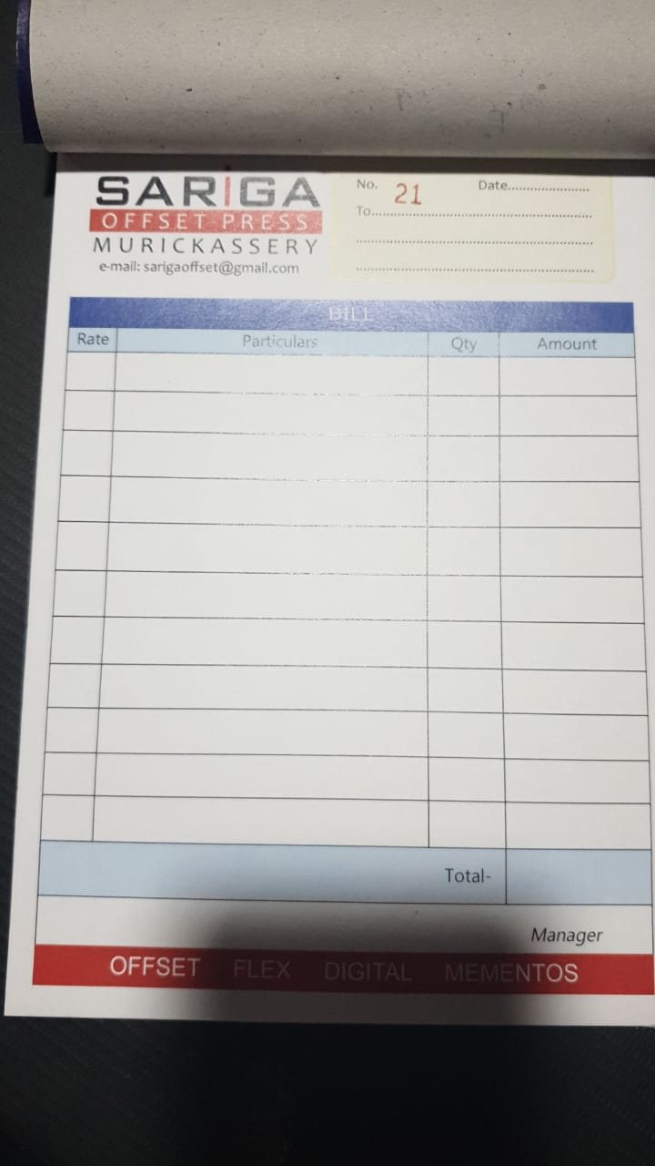

Where here there might be a chance of losing the details of the bill book and the data’s stored in it. Also there is an amount set for the printing and also maintaining this bill book of a cost 50 Rs per book, as a book consist of almost of pages of 50-100nos.

Due to these all condition I just came to the realization to make this billing process an automated service, so that there will not be any loss of the data and also there will not be any extra amount spend for the making of this bill book for the company itself.

The company which I approached is SARiGA offset press where consist of

* Book Binding
* Notice Printing
* Laser Printing
* Copy
* Flex Printing
* ID Card
* Envelops

To maintain these billing system I had introduced an automation for billing of these products.

As in the cause of Book binding and all the cost is different as an amount of human labor is used and the printing charge is also add. The cost will vary from products like vouchers, bill book etc. Its amount is calculated on the bases of the number of pages for the bill book or the voucher and also the number of copies. The book binding is of different types as spiral binding and hard binding the rate varies for that too as given below.

Also the cause of notices the charge is different as the paper quality is noted by which GSM paper is used for printing and also is it is a multicolor printing or not will also differ the amount of the notice.

For laser printing the cost will be depending upon the size or the GSM of the paper. The GSM of the paper will be varying from 100-500 and the cost is around from 25-100 RS per paper. This might also vary if there is lamination of these sheets.

Flex printing is another offset printing where this rate will depending upon the factors like

* Size of the print
* Material user
* The quality of the print
* Extra board added to the flex
* Designing charge

These factor will make the amount to vary in flex printing.

In order to maintain all these things there rate we create an automated system for this process as to calculate the company’s profit and loss. The prizing details of different categories are listed below.

**NOTICE PRINTING**

|  |  |  |  |
| --- | --- | --- | --- |
| **Paper** | **Number** | **Printing Sides** | **Amount** |
| 1/8 | 500 | 1 Side | 500 |
| 1/8 | 500 | 2 Side | 650 |
| 1/8 | 1000 | 1 Side | 650 |
| 1/8 | 1000 | 2 Side | 800 |
| A4 | 500 | 1 Side | 750 |
| A4 | 500 | 2 Side | 950 |
| A4 | 1000 | 1 Side | 1100 |
| A4 | 1000 | 2 Side | 1550 |
| Legal | 500 | 1 Side | 800 |
| Legal | 500 | 2 Side | 1200 |
| Legal | 1000 | 1 Side | 1300 |
| Legal | 1000 | 2 Side | 1700 |
| A3/Demmy Half | 500 | 1 Side | 1400 |
| A3/Demmy Half | 500 | 2 Side | 1800 |
| A3/Demmy Half | 1000 | 1 Side | 2100 |
| A3/Demmy Half | 1000 | 2 Side | 2600 |
| Crown/Demmy | 500 | 1 Side | 2900 |
| Crown/Demmy | 1000 | 1 Side | 4100 |

**BILL BOOK**

|  |  |  |
| --- | --- | --- |
| **Size** | **Number** | **Amount** |
| 1/8(50+50) | Min.2 Book | 400 |
| 1/8(50+50) | 6 Book | 600 |
| 1/8(50+50) | 10 Book | 950 |
| 1/8(50+50) | 20 Book | 1500 |
| 1/8(100+100) | Min 2 Book | 550 |
| 1/8(100+100) | 6 Book | 950 |
| 1/8(100+100) | 10 Book | 1300 |
| 1/8(50+50+50) | Min.2 Book | 600 |
| 1/8(50+50+50) | 6 Book | 850 |
| 1/8(50+50+50) | 10 Book | 1250 |
| 1/4(50+50) | Min 1 Book | 450 |
| 1/4(50+50) | 2 Book | 600 |
| 1/4 (50+50) | 5 Book | 900 |
| 1/4 (50+50) | 10 Book | 1150 |
| 1/4 (100+100) | Min. 1Book | 500 |
| 1/4 (100+100) | 2 Book | 700 |
| 1/4(100+100) | 5 Book | 1100 |
| 1/4 (100+100) | 10 Book | 1800 |
| 1/4 (50+50+50) | Min. 1Book | 500 |
| 1/4 (50+50+50) | 2 Book | 700 |
| 1/4 (50+50+50) | 5 Book | 1100 |
| 1/4 (50+50+50) | 10 Book | 1800 |
| 1/4 (50+50+50) | 20 Book | 3200 |

**RECEIPT**

|  |  |  |
| --- | --- | --- |
| **Size** | **Number** | **Amount** |
| 12/1(Counterfoil) | Min. 3 Book | 450 |
| 12/1(Counterfoil) | 6 Book | 650 |
| 12/1(Counterfoil) | 12 Book | 950 |
| 12/1(50+50) | Min. 3 Book | 550 |
| 12/1(50+50) | 6 Book | 750 |
| 12/1(50+50) | 12 Book | 1100 |
| 12/1(50+50) | 50 Book | 2550 |
| 12/1(50+50) | 100 Book | 4000 |
| 12/1(100+100) | Min. 3 Book | 700 |
| 12/1(100+100) | 6 Book | 850 |
| 12/1(100+100) | 12 Book | 1200 |
| 12/1(100+100) | 50 Book | 3400 |
| 12/1(100+100) | 100 Book | 6300 |
| 16/1(50+50) | Min. 4 Book | 400 |
| 16/1(50+50) | 12 Book | 750 |
| 16/1(50+50) | 20 Book | 950 |
| 16/1(100+100) | Min. 4 Book | 550 |
| 16/1(100+100) | 12 Book | 850 |
| 16/1(100+100) | 20 Book | 1200 |
| 16/1(50+50+50) | Min. 4 Book | 550 |
| 16/1(50+50+50) | 12 Book | 850 |
| 16/1(50+50+50) | 20 Book | 1200 |

**NOTICE MULTICOLOR**

|  |  |  |  |
| --- | --- | --- | --- |
| **Size Paper** | **Number** | **Side** | **Amount** |
| A4(100 gsm) | 1000 | 1 Side | 4500 |
| A4(100 gsm) | 1000 | 2 Side | 5000 |
| A4(100 gsm) | 2000 | 1 Side | 5600 |
| A4(100 gsm) | 2000 | 2 Side | 6000 |
| Demmy half | 1000 | 1 Side | 6300 |
| Demmy half | 1000 | 2 Side | 7400 |
| Demmy half | 2000 | 1 Side | 7500 |
| Demmy half | 2000 | 2 Side | 8500 |
| Demmy half | 3000 | 1 Side | 9000 |
| Demmy half | 3000 | 2 Side | 10200 |
| Demmy half | 4000 | 1 Side | 10600 |
| Demmy half | 4000 | 2 Side | 11600 |
| Demmy half | 5000 | 1 Side | 12600 |
| Demmy half | 5000 | 2 Side | 15300 |
| Demmy | 500 | 1 Side | 6500 |
| Demmy | 1000 | 1 Side | 8000 |
| Demmy | 2000 | 1 Side | 10600 |
| Demmy | 3000 | 1 Side | 13500 |
| Demmy | 4000 | 1 Side | 17500 |
| Demmy | 5000 | 1 Side | 21000 |

**VOUCHER**

|  |  |  |
| --- | --- | --- |
| **Size** | **Number** | **Amount** |
| 10/1,12/1 | Min. 2 Book | 350 |
| 10/1,12/1 | 6 Book | 450 |
| 10/1,12/1 | 10 Book | 750 |
| 1/8 | Min. 2Book | 350 |
| 1/8 | 6 Book | 550 |
| 1/8 | 10 Book | 900 |

**LETTER PAD**

|  |  |  |
| --- | --- | --- |
| **Size** | **Number** | **Amount** |
| 1/8 | Min. 2 Pad | 450 |
| 1/8 | 6 Pad | 750 |
| 1/8 | 10 Pad | 1100 |
| ¼ | Min 1 Pad | 450 |
| ¼ | 2 Pad | 650 |
| ¼ | 5 Pad | 1000 |
| ¼ | 10 Pad | 1500 |
| 1/4 Ex.Bond | 1 Pad | 500 |
| 1/4 Ex.Bond | 2 Pad | 750 |
| 1/4 Ex.Bond | 5 Pad | 1300 |
| 1/4 Ex.Bond | 10 Pad | 1850 |
| 1/4 Ex.Bond | Bond | 3950 |

**REGISTER**

|  |  |  |  |
| --- | --- | --- | --- |
| **Size** | **Number of Pages** | **Number of Book** | **Amount** |
| Legal | 200 Pages | 1 Book | 850 |
| Legal | 200 Pages | 2 Book | 1300 |
| Crown | 200 Pages | 1 Book | 1200 |
| Crown | 200 Pages | 2 Book | 1800 |

**LASER PRINTING**

|  |  |  |
| --- | --- | --- |
| **Paper Gsm** | **Number** | **Amount** |
| 200,170,130 | 1 | 30 |
| 200,170,130 | 2-10 | 25 |
| 200,170,130 | 11-29 | 20 |
| 200,170,130 | 30-49 | 16 |
| 200,170,130 | 50-100 | 15 |
| Sticker | 1 | 40 |
| Sticker | 2-10 | 30 |
| Sticker | 11-49 | 23 |
| Sticker | 50-100 | 18 |
| Transparent Sticker | 1 | 100 |

**VISITING CARD**

|  |  |  |  |
| --- | --- | --- | --- |
| **Paper Gsm** | **Number** | **Side** | **Amount** |
| 300 GSM | 500 | 1 Side | 650 |
| 300 GSM | 1000 | 1 Side | 900 |
| 300 GSM | 1000 | 2 Side | 1250 |
| Synthetic | 1000 | 1 Side | 1700 |

**FLEX**

|  |  |
| --- | --- |
| **Pass** | **Amount (Sq. Feet)** |
| 2 Pass | 35 |
| 3 Pass | 40 |
| Star | 45 |
| Vinyl | 50 |
| Minimal Charge | 250 |

**OTHER**

|  |  |
| --- | --- |
| Badge | 15-40 |
| ID Cards | 130 (Per Nos) |
| Envelope | 3350 (Per 1000 Nos) |
| Lamination | 10 (13X19 Size) |
| Spiral Binding | 30( 100 Pages) |
| Hard Binding | 150 (Minimal) – 500(Max) |
| Calendar | 8500 (1000 Nos)  250 (18X12 Size, 1 Nos) |
| Designing Charge | 100 (Per Hour) |

**2.1.2 Proposed System**

Where we can make whole things as in automated and there are two persons as ADMIN and EMPLOYEE, Where admin has the full access to the whole system as to edit or make changes to the product and its rate. Where EMPLOYEE can have only the function to print bill and view them as from the dates provided.

# 2.2 Functional Specifications

**2.2.1 Functions of Admin**

* **Login**
* Where the admin can login to the system.
* **Edit the products and rates**
* Admin can edit all the details of the product which are present in the system and also can add new product and also edit their rates.
* **View the bill details**
* Have the ability to view the bill details of the previous and also the present list.
* **Print bill**
* Can print bill for the particular customer.
* **Produce statements**
* Can produce statement for the particular customer by the date.

**2.2.2 Functions of Employee**

* **Login**
* Can login to the system where the admin must add the user. Only authorized user can login to the system.
* **Produce bill**
* Can produce the bill for the customer with respect to the product.
* **View bill statements**
* View the statement of the bill for any particular customer.
* **Print bill**
* Can produce the bill for a special customer’s and their product.

# 2.3 System Specification

## 2.3.1Software Interfaces

* Development Configuration
  + Machine: Windows 10, MySQL
* Implementation Configuration
  + Client Machine: Windows 7 or above
  + Server Machine: Windows 7 or above, MySQL, WAMP or XAMP

### **Specific Hardware Requirements**

* Development Configuration
  + Machine:
    - Processor –Intel i3, AMD and above version.

RAM-1GB and above.

* + - Hardware device-A monitor and keyboard with mouse.
* Implementation Configuration
  + Client Machine:
    - Hard disk -Min 250GB RAM-1GB and above.
    - Hardware device – A computer with browser.

**3.0 SYSTEM MODELLING**

# 3.1 Design Methodology

System design focuses on the final system and the process by which it is developed. It leads to transition from a user-oriented document which means system proposal a programmer-oriented document. The design methodology followed for this project is the bottom-up design strategy. In this approach, the basic sets of elements are individual modules. Each module is developed individually as a separate project and adds the modules into this as a reference if necessary. The benefit of the design is that it permits the review of the modules during the system development process. We prepare Use case diagrams to understand a system in better and simple way.

**3.1.1 USE CASE DIAGRAM**

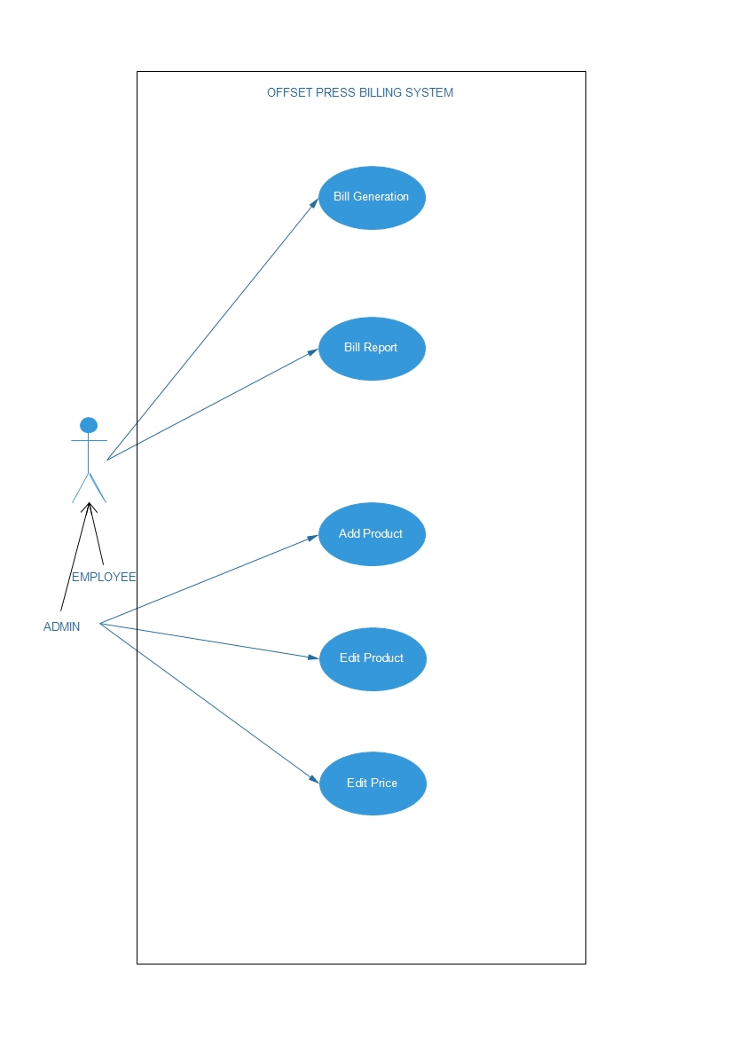

## 

**3.1.2 CLASS DIAGRAM**

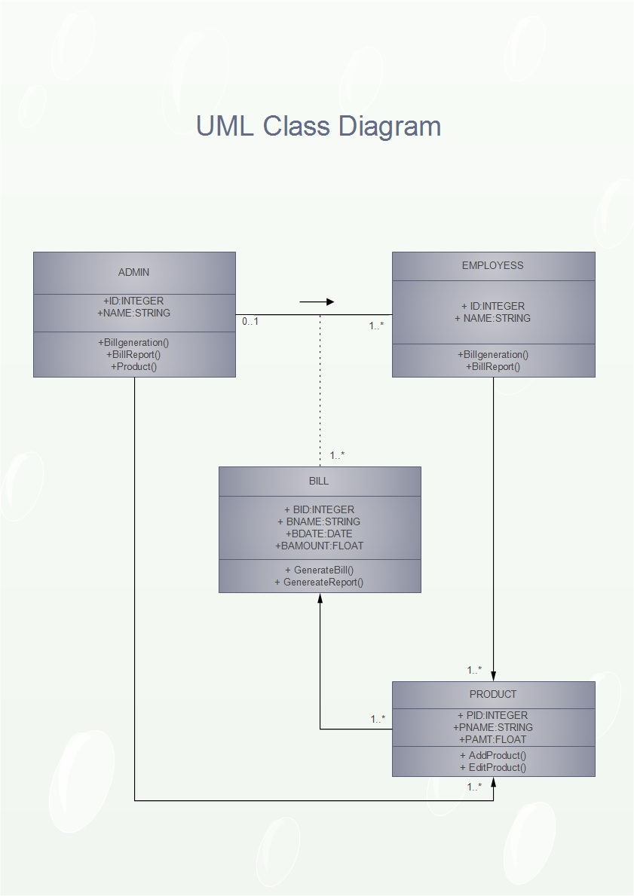

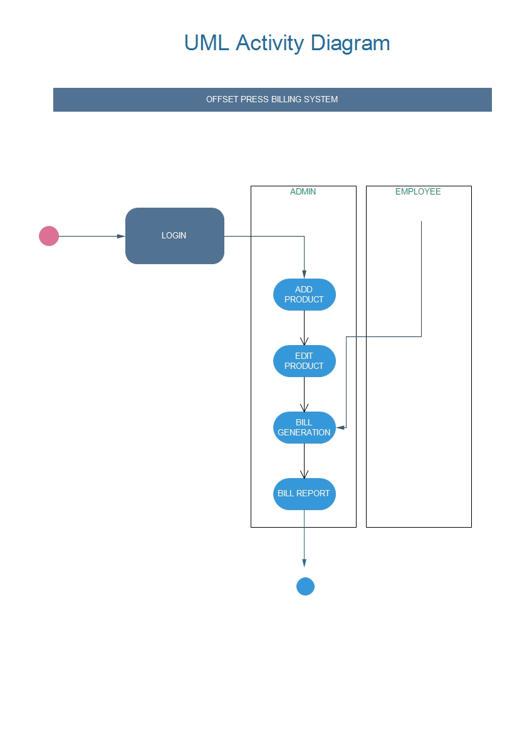**3.1.3 ACTIVITY DIAGRAM**

**3.1.4 SEQUENCE DIAGRAM (ADMIN)**

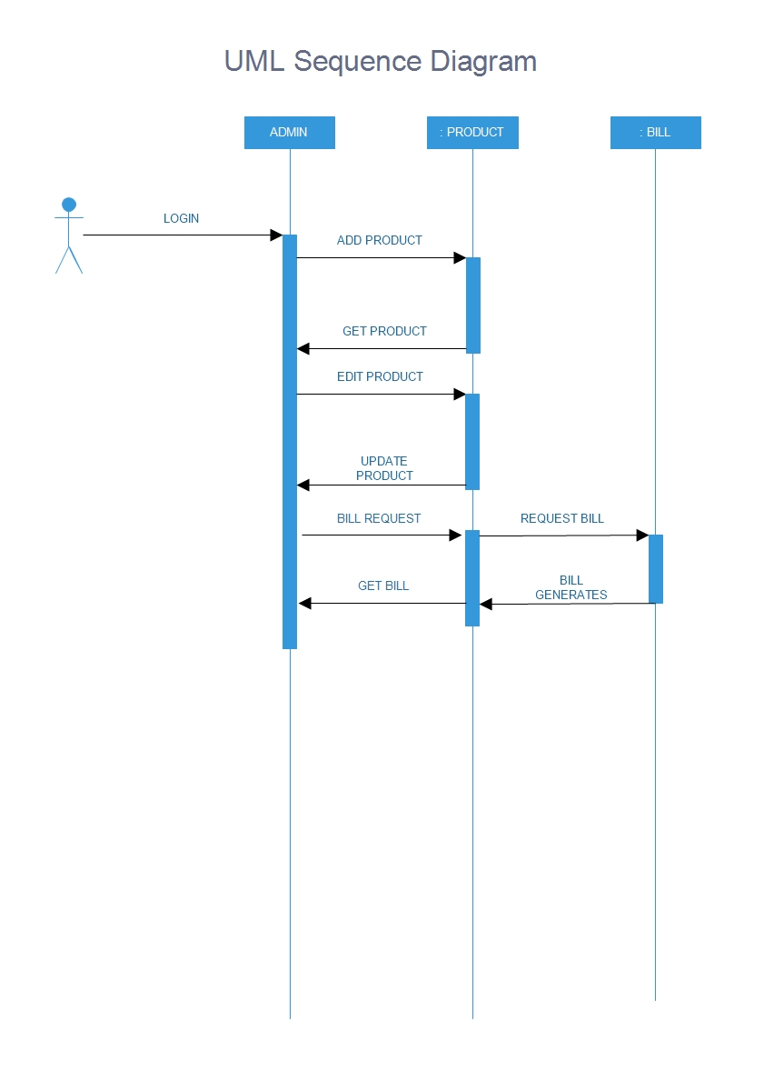

**3.1.5 SEQUENCE DIAGRAM (EMPLOYEE)**

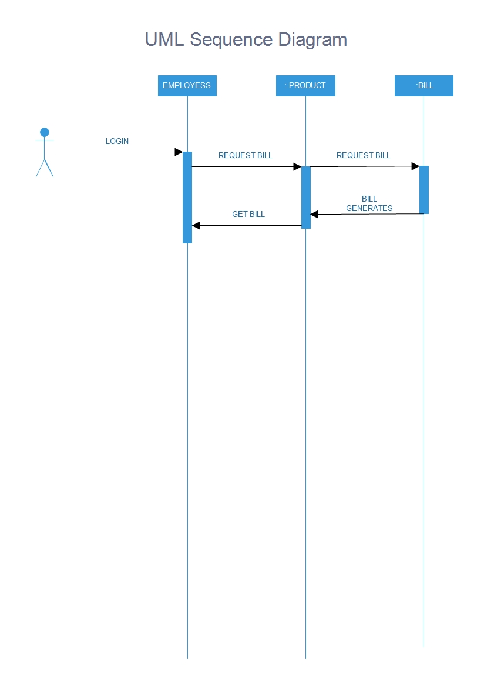

# 3.2 ER Diagram

An entity relationship diagram (ERD) shows the relationships of entity sets stored in a Data base. An entity in this context is a component of data. In other words, ER diagrams illustrate the logical structure of databases. At first glance an entity relationship diagram looks very much like a flowchart. It is the specialized symbols, and the meanings of those symbols that make it unique.

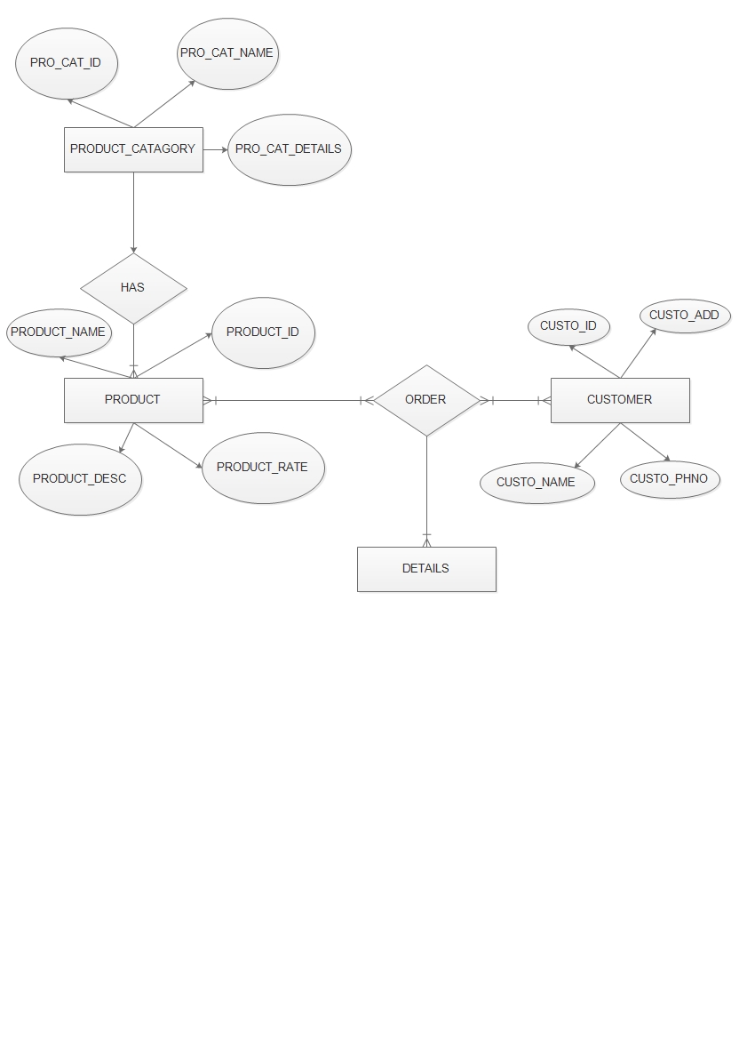

**3.3 TABLE DESIGN**

**3.3.1 PRODUCT_CATAGORY_TABLE**

|  |  |  |
| --- | --- | --- |
| **Fie ld** | **Datatype** | **De s cription** |
| Prod_Cat_ID **(PK)** | Varchar(50) | Product Category ID |
| Prod_Cat_Name | Varchar(50) | Product Category Name |
| Prod_Cat_Details | Varchar(50) | Product Category details |

The Product category Table consist of the details of the items which are of different categories.

**3.3.2 PRODUCT_TABLE**

|  |  |  |
| --- | --- | --- |
| **Field** | **Datatype** | **Description** |
| Prod_ID **(PK)** | Varchar(50) | Product ID |
| Prod_Name | Varchar(50) | Product Name |
| Prod_Rate | Double | Product Amount |
| Prod_Details | Varchar(50) | Product Details |
| Prod_Cat_ID **(FK)** | Varchar(50) | Product Category ID |

The Product Table consist of the details of all the products which are available on the store.

**3.3.3 CUSTOMER_TABLE**

|  |  |  |
| --- | --- | --- |
| **Field** | **Datatype** | **Description** |
| Cust_ID **(PK)** | Varchar(50) | Customer ID |
| Cust_Name | Varchar(50) | Customer Name |
| Cust_Address | Varchar(50) | Customer Address |
| Cust_Phone | Varchar(50) | Customer Phone Number |

The Customer Table consist of the details of the customer which the product is sold-out.

**3.3.4 ORDER_TABLE**

|  |  |  |
| --- | --- | --- |
| **Field** | **Datatype** | **Description** |
| Order_ID **(PK)** | Varchar(50) | Order ID |
| Cust_ID **(FK)** | Varchar(50) | Customer ID |
| Order_Date | Date | Order Date |
| Order_Del_Date | Date | Order Delivery Date |

Order Table consist of the details of the order which are sold out in the store by order date and delivery date.

**3.3.5 ORDER_DETAILS_TABLE**

|  |  |  |
| --- | --- | --- |
| **Field** | **Datatype** | **Description** |
| Order_ID **(FK)** | Varchar(50) | Order ID |
| Prod_ID **(FK)** | Varchar(50) | Product Id |
| Order_Qty | Int | Order Quantity |
| **Order_ID (FK) , Prod_ID (FK) complained as Primary key (PK) or Composite key** | | |

Order Details table consist of the details of the order, product and the order quantity

**3.3.6 SALES_TABLE**

|  |  |  |
| --- | --- | --- |
| **Field** | **Datatype** | **Description** |
| Order_ID **(FK)** | Varchar(50) | Order ID |
| Del_Date | Date | Original Delivery Date |
| Rate | Double | Total Amount of product |
| Discount | Double | Discount amount |

Sales table consist of the details of the sale happened in the store, with

Delivery date, order, amount discount etc.

**4.0 TESTING**

# 4.1 Introduction

The final verification and validation activity within the organization itself is done in the test plan. During testing the major activities are concerned on the examinations and modification of the source code. The various test plans done. The phone number is validated such that it shows error message as invalid phone number. The email id is validated which the expected result is invalid email if entered a wrong mail id. The password field is validated showing the error message if not correctly entered. The login of the user is blocked in case of any unauthorized login attempt occurs. The expected result here is the error message, invalid login id. The date field is validated showing that given a correct format for the date field.

**4.2 Test Cases**

**Unit Testing**

A unit is the smallest testable part of an application. Unit testing is a method of testing that verifies the individual units of source code are working properly. Rather than initially testing a program as a whole, testing is first focused on the smaller building blocks of the program. Unit testing eases the task of debugging and provide parallelism to program testing process by giving the opportunity to test multiple modules simultaneously. In this system the validity of fields in which data entered in each form and web form are checked. If the entered data are valid, then only further processing will take place.

**Integration Testing**

Data can be lost across an interface; one module can have an adverse effect on the other sub functions, when combined may not produce the desired functions. Integrated testing is the systematic testing to uncover the errors within the interface. This testing is done with simple data and the developed system has run successfully with this simple data. The need for integrated testing is to find the overall system performance. While developing the system, each module is developed individually and integrated with present system. Modules are integrated by adding the module as a reference in other modules

**Table 4.1 Test Table**

|  |  |  |  |  |  |
| --- | --- | --- | --- | --- | --- |
| **Test**  **Case**  **No** | **Test Data** | **Cases** | **Excepted Result** | **Actual Result** | **Remarks** |

# 5.0 IMPLEMENTATION

## 5.1 Introduction

Implementation is the stage in the project where the theoretical design is turned into a working system. Implementation is the final and important phase. The most critical stage for achieving a successful new system and for giving the users confidence that the new system will work and be effective. The system can be implemented only after thorough testing is done and only if it is found to working according to the specification. This method also offers the high security since it is implemented after identifying and handling all types of transactions while using the new system. Implementation phase include the training that should be provided for the chosen staff.

## 5.2. Installation Procedure

The software can be installed in the following simple steps.

In Central Database Server

Install Apache MySqL Server

## 5.3 Implementation Plan

In a direct cutover conversion, the old system is discarded and the new system takes over all at once, it is essentially turning the old system off and turning the new system on. This approach can be the least expensive of the different methods and can occur in the quickest time. A direct cutover conversion may be the only option if the old and new systems cannot co-exist in any form. The greatest risk is the impact that errors and failures would have on the organization. The timing of

this type of conversion is a key element of its success. The riskiest strategy for new systems installation, the direct cutover conversion can be low cost and the benefits of the new system can be realized without delay.

Implementation steps include the following:

* Develop an error free & reliable website.
* Find an affordable and efficient web hosting service.
* Collect the username and password provided by the hosting service.
* Upload the website to allocated web space.
* Connect the required website with the corresponding website for the smooth functioning.

**6. 0 CONCLUSION**

The project entitled “OFFSET BILLING SYSTEM” has been developed as a web site as to promote the shop to the next level of automation and also to have a centralized database to store the information of the shop details as the main function of billing system. Where the employee of the admin of the shop can add the customer details and print the bill to that specified customer and also store there information to the further pourpose.

**7. 0 APPENDIX**

**7.1 Appendix A**

**7.2 Appendix B**

**7.3 Appendix C**